Hydraulic UTM with PC Based control and measurement system
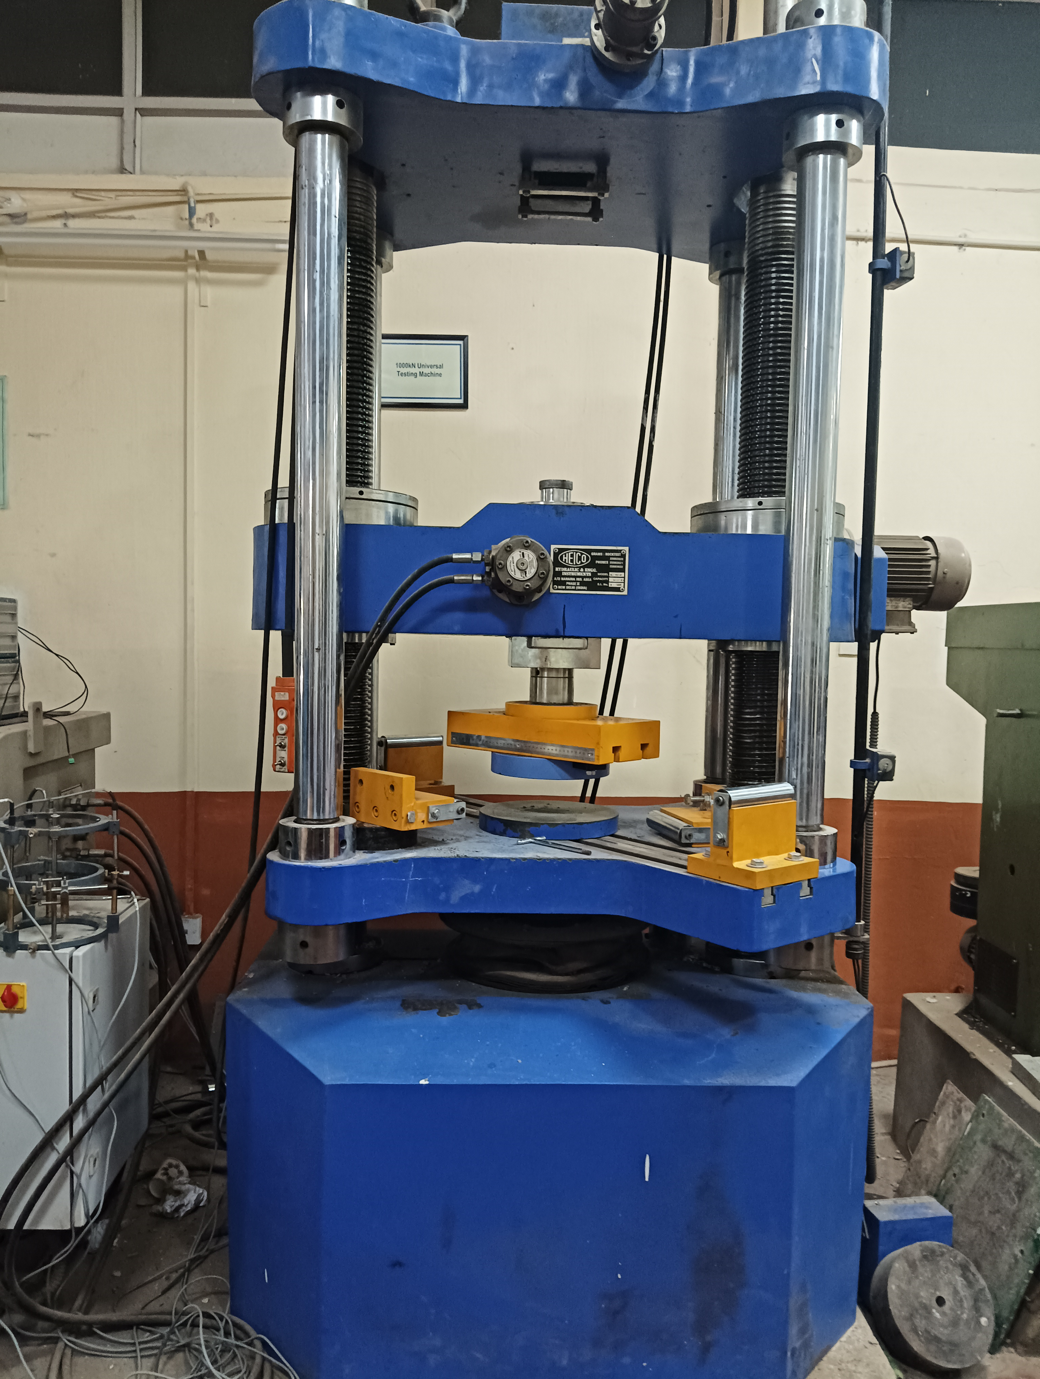 | Name of the equipment:  Hydraulic UTM with PC Based control and measurement system  Make & Model:  Make: Hydraulic engineering and instruments & Model: HL-590.25  I-Stem Registration ID-  ………………  Category of Instrument  (Advanced Manufacturing facility / Characterization and Testing / Computational Facility / Bioscience and Technology / Sample preparation)  Types of Analysis / Testing  Compression, Tension, bending etc  Application:  It has to be planned based on the need  Description of Instrument  This machine is designed to evaluate the mechanical properties of materials by conducting various tests, including tensile, compression, bending
Booking Details

Book through I-STEM:  https://www.istem.gov.in/  Slot Booking Link  I-STEM Slot Booking link for External User |  | Booking available for  Internal and External Both  Requisition form for  Internals  Externals  Contact Details
Faculty In-charge:  Dr. Jayachandran K  Email ID:  jk@nitc.ac.in  Phone number:  +91944226441 | Technical Staff:  Noushad K K (TA) noushadkk@nitc.ac.in  Jeyeshkumar (TA)  jeyesh@nitc.ac.in  Nithya B S (TA) nithyabs@nitc.ac.in |  | Department  CED  Office Email ID  cedoffice@nitc.ac.in  Location  Structural laboratory, Department of Civil engineering  Lab Phone No  04952286840
Features, Working Principle and Specifications

Features of the equipment  - Easy cross head movement on the two pillars to adjust the gap with easy operation for specimen as per requirement.  - Easily changeable Hydraulically operated Grips for Tension test.  - Fully Computer Controlled operation with User friendly Software.  - Controlling on both Load (kN/sec)/stress (N/mm2/sec), Displacement (mm/sec) or Strain Control basis.  - Facility to study Post failure behaviors of specimens.  - Inching/Release operation to set Sample.  - Auto release facility after specimen failure. | Unique features/Measurement capabilities, if any  - Fully Automatic Servo Controlled Universal Testing Machine with hydraulically operated open crosshead and front loading jaws
Instrument Technical Description and Major Specifications (This Specifications Limited to Major 5)  - PC-based digital control system for precise operation and data acquisition | Measurement/Sample specifications:  • Universal testing machine for concrete typically have a load capacity upto 1000 kN,
Type of Sample Required for Analysis / Testing (Quantity, Pre-Preparation, State etc.) Guidelines for Sample Submission – User Instructions

- The particular focus on concrete specimens such as cylinders, beams, or cubes
Test Specimen Sizes:
Concrete cylinders (e.g., 150 mm x 300 mm or 100 mm x 200 mm).
Concrete cubes (e.g., 150 mm or 100 mm sides).
Concrete beams (usually 150 mm x 150 mm x 700 mm, 100 x 100 x 500 mm or custom sizes).

- Steel sample – subject to suitable grip availability for the given diameter
User Charges Rs. (GST Extra)

Internal | External Academic Institutes | National R&D Lab | Industry
1000/- per hour | 2000/- per hour | 3000/- per hour | 4000/- per hour

