500kN SERVO HYDRAULIC ACTUATOR SYSTEM

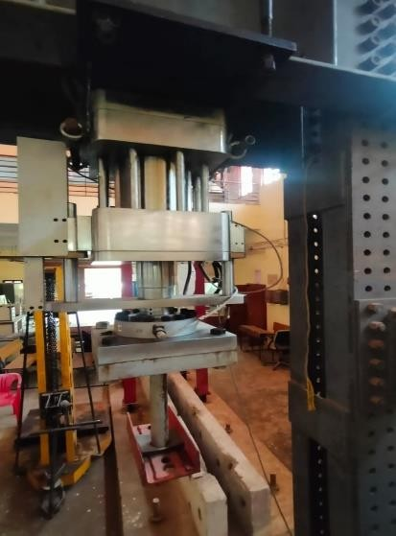 | Name of the equipment:  500kN Servo Hydraulic Actuator system  Make & Model:  BISS, Bangalore  Bi-03-Ec-801-05  I-Stem Registration ID-  ……………………..  Category of Instrument  (Advanced Manufacturing facility / Characterization and Testing / Computational Facility / Bioscience and Technology / Sample preparation)  Types of Analysis / Testing  - Quasi static cyclic load testing on beam column joint  - Cyclic three-point load testing on beam  - Lateral cyclic load test on concrete frame  Application:  - Strain controlled load application  - Quasi static reverse cyclic loading.  Description of Instrument  A 500kN Servo Hydraulic Actuator system  bio-printer for engineers and researchers
Booking Details

Book through I-STEM:  https://www.istem.gov.in/  Slot Booking Link  I-STEM Slot Booking link for External User  Contact Details |  | Booking available for  Internal and External Both  Requisition form for  Internals  Externals
Faculty In-charge:  Dr. Ajeesh S. S.  Email ID:  ajeeshss@nitc.ac.in  Phone number:  0495 228 6238 | Technical Staff:  Noushad K K (TA) noushadkk@nitc.ac.in  Jeyeshkumar (TA)  jeyesh@nitc.ac.in  Nithya B S (TA) nithyabs@nitc.ac.in |  | Department  CED  Office Email ID  cedoffice@nitc.ac.in  Location  Structural laboratory, Department of Civil engineering  Lab Phone No  04952286840
Features, Working Principle and Specifications

Features of the equipment  Servo hydraulic actuator is double ended double acting high precession linear actuator. | Unique features/Measurement capabilities, if any
Instrument Technical Description and Major Specifications (This Specifications Limited to Major 5)  Model: AC-02-0250S  Capacity: Compression 500kN, Tension 350kN | Measurement/Sample specifications:  Stroke(mm): ±75mm  Actuator area(mm2): Compression 25446.9; Tension 15943.58  Rod Thread (Depth) in mm: M50x2(70)
Type of Sample Required for Analysis / Testing (Quantity, Pre-Preparation, State etc.) Guidelines for Sample Submission – User Instructions

- Scale down model which matches with the Reaction frame and supporting floor.
- The expected failure load is below 100kN
- Any specific support condition required need to fabricated

User Charges Rs. (GST Extra)

S.NO. | Type of Analysis / Testing | Internal - | External Academic Educational Institutes | National R&D Labs | Industry
1 | Axial Compression or Flexure (Cyclic/Monoto nic) | 1000 per Hour | 2000 per Hour | 3000 per Hour | 4000 per Hour
2 | Axial Compression or Flexure  (Cyclic/Monoto nic) | 1000 per Hour | 2000 per Hour | 3000 per Hour | 4000 per Hour
3 | Axial Compression or Flexure (Cyclic/Monoto nic) | 1000 per Hour | 2000 per Hour | 3000 per Hour | 4000 per Hour

