Booking Details
TOWING TANK WITH CARRIAGE SYSTEM

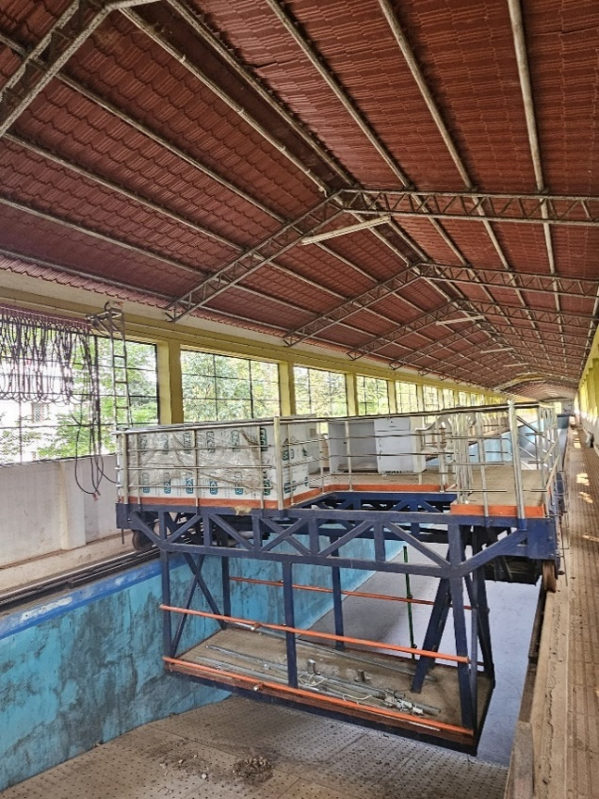 | Name of the equipment:  TOWING TANK WITH CARRIAGE SYSTEM  Make & Model:  Allied Engineering company  I-Stem Registration ID-  3222331  Category of Instrument  Testing  Types of Analysis / Testing  Fabrication  Application:  - Wave Behaviour: Reflection and transmission analysis.  - Model Testing: Scale models of wave energy converters and coastal protection structures.  - Structural Impact: Pressure and force studies on coastal structures.  Description of Instrument  Wave flume dimensions 40m*2m*2m , Paddle unit holding frame , Plunger unit height maintain unit ,Capable of generating regular waves with wave height from 3 to 8 cm and period ranging between 0.7 to 1.4 s

Book through I-STEM:  https://www.istem.gov.in/  Slot Booking Link  I-STEM Slot Booking link for External User | Booking available for  Internal and External Both  Requisition form for  Internals  Externals

Faculty In-charge:  Dr Anand K.V  Email ID:  kvanand@nitc.ac.in  Phone number:  +91-9940084140 | Contact Details  Technical Staff:  Sharafudheen CT (TA) Sharafudheenct@nitc.ac.in  9847696031 | Department  CED  Office Email ID  cedoffice@nitc.ac.in  Location  Offshore lab, Department of Civil Engineering  Lab Phone No  0495-2286246

Features, Working Principle and Specifications

Features of the equipment  ✔ Large Towing Tank (100m × 4m × 4m) for hydrodynamic testing  ✔ Robust Carriage System (4.3m × 3m) with precision wheels on a round track  ✔ Dual Siemens Motors ensuring smooth operation  ✔ Variable Speed Control up to 3.5 m/s | Unique features/Measurement capabilities, if any  ➤ Ship manoeuvring & stability studies  ➤ Hydrodynamic performance analysis  ➤ Propeller model testing
Instrument Technical Description and Major Specifications (This Specifications Limited to Major 5)  - Tank Size: 100m × 4m × 4m  - Carriage Frame: 4.3m × 3m  - Drive System: Siemens IE2 series TEFC motors  - Max Speed: 3.5 m/s | Measurement/Sample specifications:  - Testing Capability: Scale model testing  - Instrumentation Setups: Must be arranged based on testing requirements  Type of Sample Required for Analysis / Testing (Quantity, Pre-Preparation, State etc.) Guidelines for Sample Submission – User Instructions

- Sample Type: Scaled hydrodynamic models
- Pre-preparation: Must be structurally stable
- User Instructions: Submit instrumentation plans before testing
User Charges Rs. (GST Extra)

Sl no | Type of Analysis / Testing | Internal | External Academic Institutes | National R&D Lab | Industry
1 | Testing | 2000/day | Rs 1500/hr | Rs 2000/hr | Rs 5000/hr
2 | Pre-testing installations | NA | Rs 2000/day | Rs 5000/day | Rs 10000/day
3 | Post testing removal of models and other setup (no charge for first 3 working days) | Rs 2000/day | Rs 5000/day | Rs 5000/day | Rs 10000/day

