CHANNEL WAVE GAUGE SYSTEM & ACCESSORIES
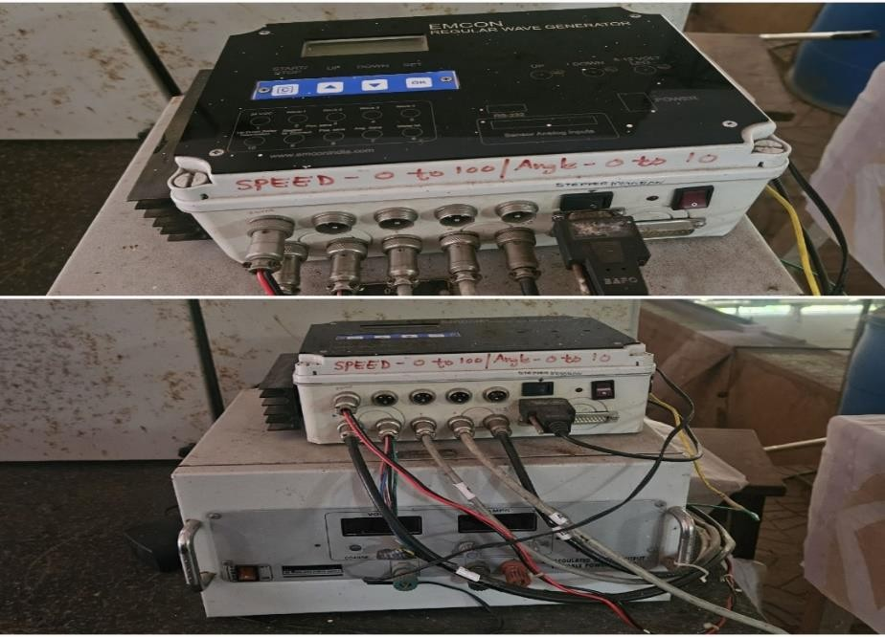 | Name of the equipment:  Channel Wave Gauge System & Accessories  Make & Model:  EMCON  I-Stem Registration ID-  …………………..  Category of Instrument  Testing  Types of Analysis / Testing  Fabrication  Application:  Used for generating and analysing wave behaviour in coastal and offshore structure models. Supports wave data acquisition, signal measurement, and model testing.  Description of Instrument  A wave generation and signal measurement system with adjustable plunger motion (speed: 0–100 units; angle: 0–10°) and a 10-channel data acquisition system (17 Hz). Integrated for coastal and offshore model studies
Booking Details
Contact Details
Book through I-STEM:  https://www.istem.gov.in/  Slot Booking Link  I-STEM Slot Booking link for External User | Booking available for  Internal and External Both  Requisition form for  Internals  Externals

Faculty In-charge:  Dr Anand K.V  Email ID:  kvanand@nitc.ac.in  Phone number:  +91-9940084140 | Technical Staff:  Sharafudheen CT (TA) Sharafudheenct@nitc.ac.in  9847696031 | Department  CED  Office Email ID  cedoffice@nitc.ac.in  Location  Offshore lab, Department of Civil Engineering  Lab Phone No  0495-2286246

Features, Working Principle and Specifications

Type of Sample Required for Analysis / Testing (Quantity, Pre-Preparation, State etc.) Guidelines for Sample Submission – User Instructions
Features of the equipment  - Controlled wave generation system  - Adjustable plunger for height and motion  - Integrated data acquisition for signal analysis | Unique features/Measurement capabilities, if any  - Real-time wave signal measurement  - Data collection via 10-channel DAQ (17 Hz)  - Plunger motion control with variable speed and angle
Instrument Technical Description and Major Specifications (This Specifications Limited to Major 5)  - Plunger Motion Control System: Speed adjustable from 0 to 100 units; angle adjustable between 0 to 10 degrees.  - Data Acquisition System: 10 channels with a measurement capability of 17 Hz. | Measurement/Sample specifications:  - Sample Type: Scaled models for coastal studies  - Preparation: Stable, well-constructed models  - Requirements: Pre-defined instrumentation setup

- Sample Type: Designed to measure signals; experimental setup should be planned based on specific needs.
- Pre-preparation: Not specified; depends on the experimental design.
- User Instructions: Users must plan their experiments to utilize the system's capabilities effectively.
User Charges Rs. (GST Extra)

Sl no | Type of Analysis / Testing | Internal | External Academic Institutes | National R&D Lab | Industry
1 | It is to measure the signals, so has to be planned based on the need | 2000/day | Rs 1500/hr | Rs 2000/hr | Rs 5000/hr

