HAMBURG WHEEL TRACKER

HAMBURG WHEEL TRACKER

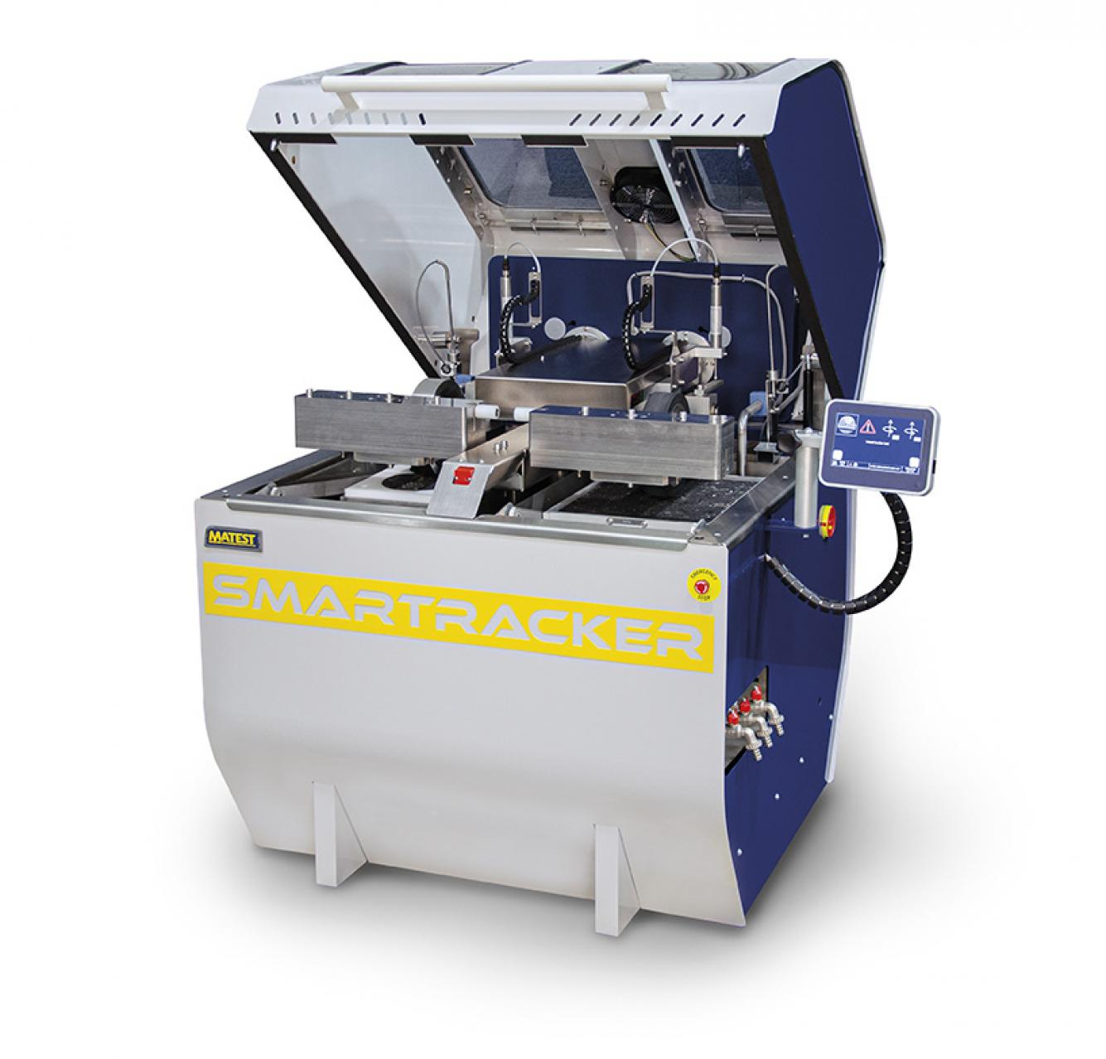 | Name of the equipment:  Hamburg Wheel Tracker  Make & Model:  BO38AM  I-Stem Registration ID-  3222450  Category of Instrument  Characterization and Testing  Types of Analysis / Testing  Rutting Test  Application:  It is suitable for testing in various conditions, including wet and dry samples, and meets international standards such as EN, AASHTO, and BS.  Description of Instrument  A patented wheel tracking device for testing Hot Mix Asphalt resistance to rutting and moisture sensitivity.

Booking Details  Book through I-STEM:  https://www.istem.gov.in/  Slot Booking Link  I-STEM Slot Booking link for External User | Booking available for  Internal and External Both  Requisition form for  Internals  Externals
Contact Details

Faculty In-charge:  Dr. M. Sivakumar  Email ID:  sivakumarm@nitc.ac.in  Phone number:  0495-2286232 | Technical Staff:  Abhiraj A R  abhirajar@nitc.ac.in  Ajin Das C K  ajindasck@nitc.ac.in  Chandni P R  chandnipr@nitc.ac.in | Department  Department of Civil Engineering  Office Email ID  cedoffice@nitc.ac.in  Location  Pavement Engineering Laboratory  Lab Phone No.  0495-2286243

Features, Working Principle and Specifications
Features of the equipment  - Simultaneous wet and dry testing  - Independent wheel motors  - Automatic testing  - Real-time monitoring  - Touch-screen interface  - Data export | Unique features/Measurement capabilities,  if any  - Innovative wheels roll off Mechanism (patented)  - Real-time results plot  - Measurement of creep slope, stripping inflection point, and stripping slope  - Precise rut depth transducers (25 mm ± 0.1 mm)  - Advanced temperature control
Instrument Technical Description and Major Specifications (This Specifications Limited to Major 5)  - Wheel load: 705 N  - Wheel speed: 20-30 cycles/minute  - Temperature control range: from ambient up to 75°±1 °C  - Table travel: 230, 260, 280 mm  - Power supply: 220V 50-60Hz | Measurement/Sample specifications:  - Sample diameter- 150mm  - Sample shape- cylindrical  - Number of samples for 1 test- 2 samples  - Type of sample- Hot mix / Cold mix
Type of Sample Required for Analysis / Testing (Quantity, Pre-Preparation, State etc.) Guidelines for Sample Submission – User Instructions

User Charges Rs. (GST Extra)
- Sample quantity: One sample per test
- Preparation: Ensure the sample is properly filled into the mould and secured before testing
- Submission guidelines:
  - Fill the mould with the HMA sample, ensuring it is properly compacted.
  - Ensure the device is set to the correct test parameters.
  - Start the test and monitor the results.
- Minimum No. of Days: Required for Analysis: 1 day (test completion) to 3 days (data analysis and report preparation)

Internal | External Academic Institutes | National R&D Lab | Industry
1500/- per test | 2000/- per test | 2500/- per test | 4500/- per test

