BASIC HYDRAULIC SYSTEM- WAVE FLUME 40M X 2M X 2M
-
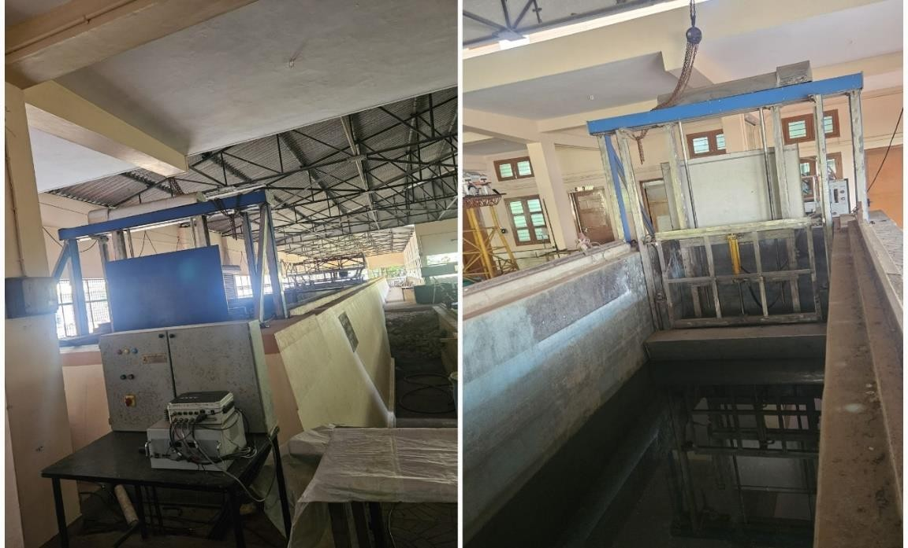 | Name of the equipment:  Basic hydraulic system & Wave maker unit  Make & Model:  Allied Engineering company  I-Stem Registration ID-  3222332  Category of Instrument  Testing  Types of Analysis / Testing  Fabrication  Application:  - Wave Behavior: Reflection and transmission analysis.  - Model Testing: Scale models of wave energy converters and coastal protection structures.  - Structural Impact: Pressure and force studies on coastal structures.  Description of Instrument  • Wave flume dimensions 40m*2m*2m , Paddle unit holding frame , Plunger unit height maintain unit ,Capable of generating regular waves with wave height from 3 to 8 cm and period ranging between 0.7 to 1.4 s
Booking Details
Contact Details
Book through I-STEM:  https://www.istem.gov.in/  Slot Booking Link  I-STEM Slot Booking link for External User | Booking available for  Internal and External Both  Requisition form for  Internals  Externals

Faculty In-charge:  Dr Anand K.V  Email ID:  kvanand@nitc.ac.in  Phone number:  +91-9940084140 | Technical Staff:  Sharafudheen CT (TA) Sharafudheenct@nitc.ac.in  9847696031 | Department  CED  Office Email ID  cedoffice@nitc.ac.in  Location  Offshore lab, Department of Civil Engineering  Lab Phone No  0495-2286246
Type of Sample Required for Analysis / Testing (Quantity, Pre-Preparation, State etc.) Guidelines for Sample Submission – User Instructions
Features, Working Principle and Specifications
Features of the equipment  ✔ Wave Generation System with a versatile paddle unit  ✔ Adjustable Plunger Unit for precise height control  ✔ Capable of Generating Regular Waves with controlled height and period | Unique features/Measurement capabilities, if any  ➤ Wave Reflection & Transmission Analysis  ➤ Scale Model Testing for Coastal & Offshore Structures  ➤ Pressure & Force Measurement on Coastal Structures
Instrument Technical Description and Major Specifications (This Specifications Limited to Major 5)  - Wave Flume Dimensions: 40m × 2m × 2m  - Structural Components: Paddle unit holding frame, plunger unit height adjustment mechanism  - Wave Generation: Regular waves with controlled parameters  - Wave Parameters (Wave Height & Wave Period) | Measurement/Sample specifications:  - Testing Capability: Scale model testing  - Instrumentation Setups: Must be arranged based on testing requirements

- Sample Type: Scaled model for wave testing
- Pre-preparation: Model should be well-constructed for stability
- User Instructions: Necessary instrumentation must be specified before testing
- Testing & Analysis Details
- Types of Samples Analyzed: Scale models of coastal structures, wave energy converte
User Charges Rs. (GST Extra)

Sl no | Type of Analysis / Testing | Internal | External Academic Institutes | National R&D Lab | Industry
1 | Testing | 2000/day | Rs 1500/hr | Rs 2000/hr | Rs 5000/hr
2 | Pre-testing installations | NA | Rs 2000/day | Rs 5000/day | Rs 10000/day
3 | Post testing removal of models and other setup (no charge for first 3 working days) | Rs 2000/day | Rs 5000/day | Rs 5000/day | Rs 10000/day

