Total Organic Carbon Analyser
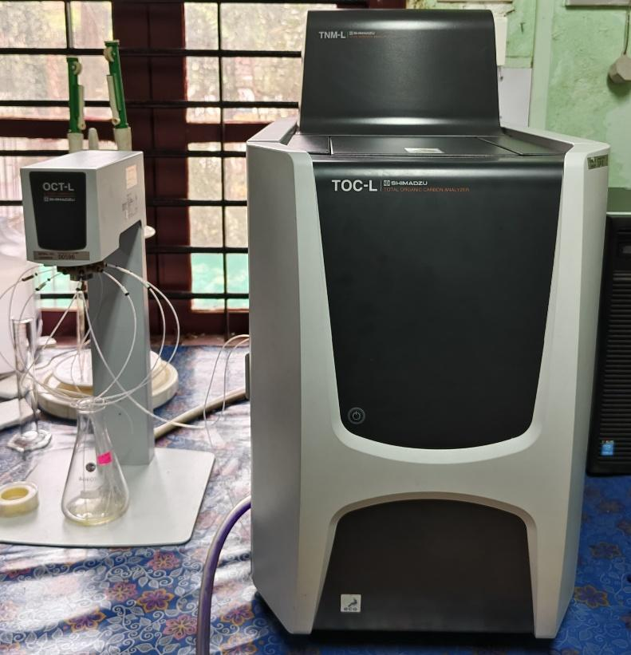 | Name of the equipment:  Total Organic Carbon Analyser  Make & Model:  Shimadzu H544354 TOC Analyzer  I-Stem Registration ID-  ……………………..  Category of Instrument  Testing and Characterisation  Types of Analysis / Testing  - Total Organic Carbon (TOC) Measurement  - Total Carbon (TC) Measurement  - Total Nitrogen (TN) Measurement  - Non-Purgeable Organic Carbon (NPOC) Analysis  Application:  - Pharmaceutical analysis  - Environmental testing (viz. VOC analysis)  - Forensics & toxicology  - Food & flavor analysis  - Petrochemical & industrial chemistry  Description of Instrument  TC, IC, NPOC and TN measurement  Measurement range from 4 μg/L to 30,000 mg/L  680 °C Combustion, Catalytic Oxidation/ NDIR  Detection Method for TOC at 720 °C
Booking Details

Book through I-STEM:  https://www.istem.gov.in/  Slot Booking Link  I-STEM Slot Booking link for External User | Booking available for  Internal and External Both  Requisition form for  Internals  Externals
Faculty In-charge:  Dr. Anantha Singh T S  Dr. Bhaskar S  Email ID:  singh87@nitc.ac.in  bhaskars@nitc.ac.in  Phone number:  Anantha Singh: +91-8758790511  Bhaskar S: +91-9742720843 | Contact Details  Technical Staff:  Fashid V C (TA) fashidvc@nitc.ac.in  Amardeep KV (Technician)  amardipkumarv@nitc.ac.in | Department  CED  Office Email ID  cedoffice@nitc.ac.in  Location  Environmental Engineering Laboratory, Department of Civil Engineering  Lab Phone No  0495 228 6247
Type of Sample Required for Analysis / Testing (Quantity, Pre-Preparation, State etc.)
Features, Working Principle and Specifications
Features of the equipment  - High-temperature catalytic oxidation (HTCO) method  - Automatic sample dilution and acidification  - Low maintenance with self-cleaning function  - User-friendly software for data analysis | Unique features/Measurement capabilities, if any  - Detection range: 0.001 mg/L – 30,000 mg/L  - Simultaneous TOC & TN (Total Nitrogen) measurement
Instrument Technical Description and Major Specifications  (This Specifications Limited to Major 5)  - Measurement Principle: High-temperature combustion (680°C)  - Detection Method: NDIR (Non-Dispersive Infrared) sensor  - Sample Volume: 0.1 – 2 mL (auto-injection)  - Analysis Time: 4-6 minutes per sample  - Calibration: Automatic multi-point calibration | Measurement/Sample specifications:  - Sample State: Liquid (aqueous solutions)  - Particle Size: Must be < 0.45 µm (filtered if necessary)  - pH Range: 2-11 (acidification may be required for NPOC)  - Maximum Salinity: 5% (w/v) (higher levels may require dilution)

- Quantity: 10-20 mL (volume depends on expected TOC/TN levels)
- Pre-Preparation:
  - Must be filtered (0.45 µm) to remove suspended solids.
  - Avoid samples with high volatility (use TC mode if necessary).
- Type of Samples Accepted:
  - Drinking water, wastewater, industrial effluents, research samples.
Guidelines for Sample Submission – User Instructions

- Label samples clearly with expected TOC/TN range.
- Indicate if TN measurement is required (if TN unit is installed).
- Maximum No. of Samples Accepted at a Time: 50 (autosampler capacity).
- Turnaround Time: 1-2 days (varies with sample load).
- Samples exceeding 5% salinity must be pre-diluted.
- No bacterial/fungal samples (instrument is for chemical analysis only).
User Charges Rs. (GST Extra)

Internal | External Academic Institutes | National R&D Lab | Industry
1500 per sample | 3000 per sample | 3000 per sample | 6000 per sample

