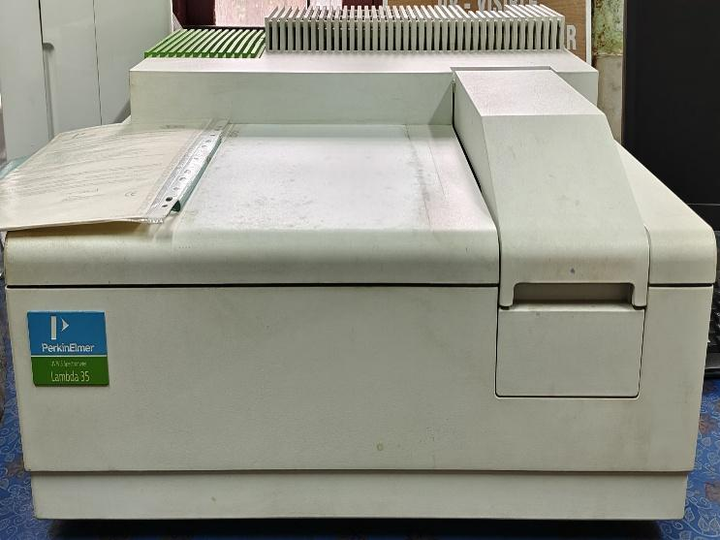 | UV/VIS SPECTROPHOTOMETER  Name of the equipment:  UV Visible Spectrophotometer  Make & Model:  Perkin Elmer Lambda 35  I-Stem Registration ID-  ………………3220813  Category of Instrument  Analytical Chemistry  Types of Analysis / Testing  - Absorbance & transmittance measurements  - Quantitative analysis of solutions  Application:  - Water quality analysis (nitrates, phosphates, heavy metals)  - Chemical concentration determination  - Environmental pollutant monitoring  - Pharmaceutical & biochemical assays  Description of Instrument  A double-beam UV/VIS spectrophotometer for accurate optical measurements in environmental, chemical, and biological research.
Booking Details

Book through I-STEM:  https://www.istem.gov.in/  Slot Booking Link  I-STEM Slot Booking link for External User | Booking available for  Internal and External Both  Requisition form for  Internals  Externals
Contact Details

Faculty In-charge:  Dr. Anantha Singh T S  Dr. Bhaskar S  Email ID:  singh87@nitc.ac.in  bhaskars@nitc.ac.in  Phone number:  Anantha Singh: +91-8758790511  Bhaskar S: +91-9742720843 | Technical Staff:  Fashid V C (TA) fashidvc@nitc.ac.in  Amardeep KV (Technician)  amardipkumarv@nitc.ac.in | Department  CED  Office Email ID  cedoffice@nitc.ac.in  Location  Environmental Engineering Laboratory, Department of Civil Engineering  Lab Phone No  0495 228 6247

Features, Working Principle and Specifications

Features of the equipment  - Double-beam optics for high stability & accuracy  - Wavelength range: 190–1100 nm  - Large sample compartment for various cuvette sizes  - User-friendly UV WinLab software for data analysis  - Automatic wavelength calibration & validation | Unique features/Measurement capabilities, if any  - High photometric accuracy (±0.003 A at 1 A)  - Programmable scanning speeds (5–3000 nm/min)  - Built-in diagnostics for performance verification
Instrument Technical Description and Major Specifications  (This Specifications Limited to Major 5)  - Wavelength Range: 190–1100 nm  - Bandwidth: 1 nm (fixed)  - Photometric Accuracy: ±0.003 A (at 1 A)  - Light Source: Tungsten halogen (VIS) & Deuterium lamp (UV)  - Detector Type: Silicon photodiode | Measurement/Sample specifications:  - Sample Type: Liquid (aqueous/organic solutions)  - Cuvette Compatibility: 10 mm standard (quartz/glass/plastic)  - Absorbance Range: 0–3 A (recommended: 0.1–1.5 A for best accuracy)  - Concentration Range: Must be within Beer-Lambert law linearity
Type of Sample Required for Analysis / Testing (Quantity, Pre-Preparation, State etc.)

- Quantity: 2–3 mL (minimum for cuvette filling)
- State: Liquid (homogeneous, no bubbles/particulates)
- Pre-Preparation:
  - Filter turbid samples
  - Degas if bubbly
  - Solvent Matched Blank Required
  - pH adjustment may be needed for certain analytes
- Type of Samples Analyzed: Solutions (e.g., DNA, proteins, dyes)
Guidelines for Sample Submission – User Instructions

- Provide solvent blanks for baseline correction.
- Label samples clearly with concentration/solvent details.
- Avoid overloading absorbance (>1.5 A may require dilution).
- Maximum Samples per Run: 1 (manual)
- Minimum Analysis Time: 1–5 minutes per sample.
User Charges Rs. (GST Extra)

Internal | External Academic Institutes | National R&D Lab | Industry
500/- per hour | 1500/- per hour | 1500/- per hour | 3000/- per hour

