Sterio Microscope with 5MP HD Camera
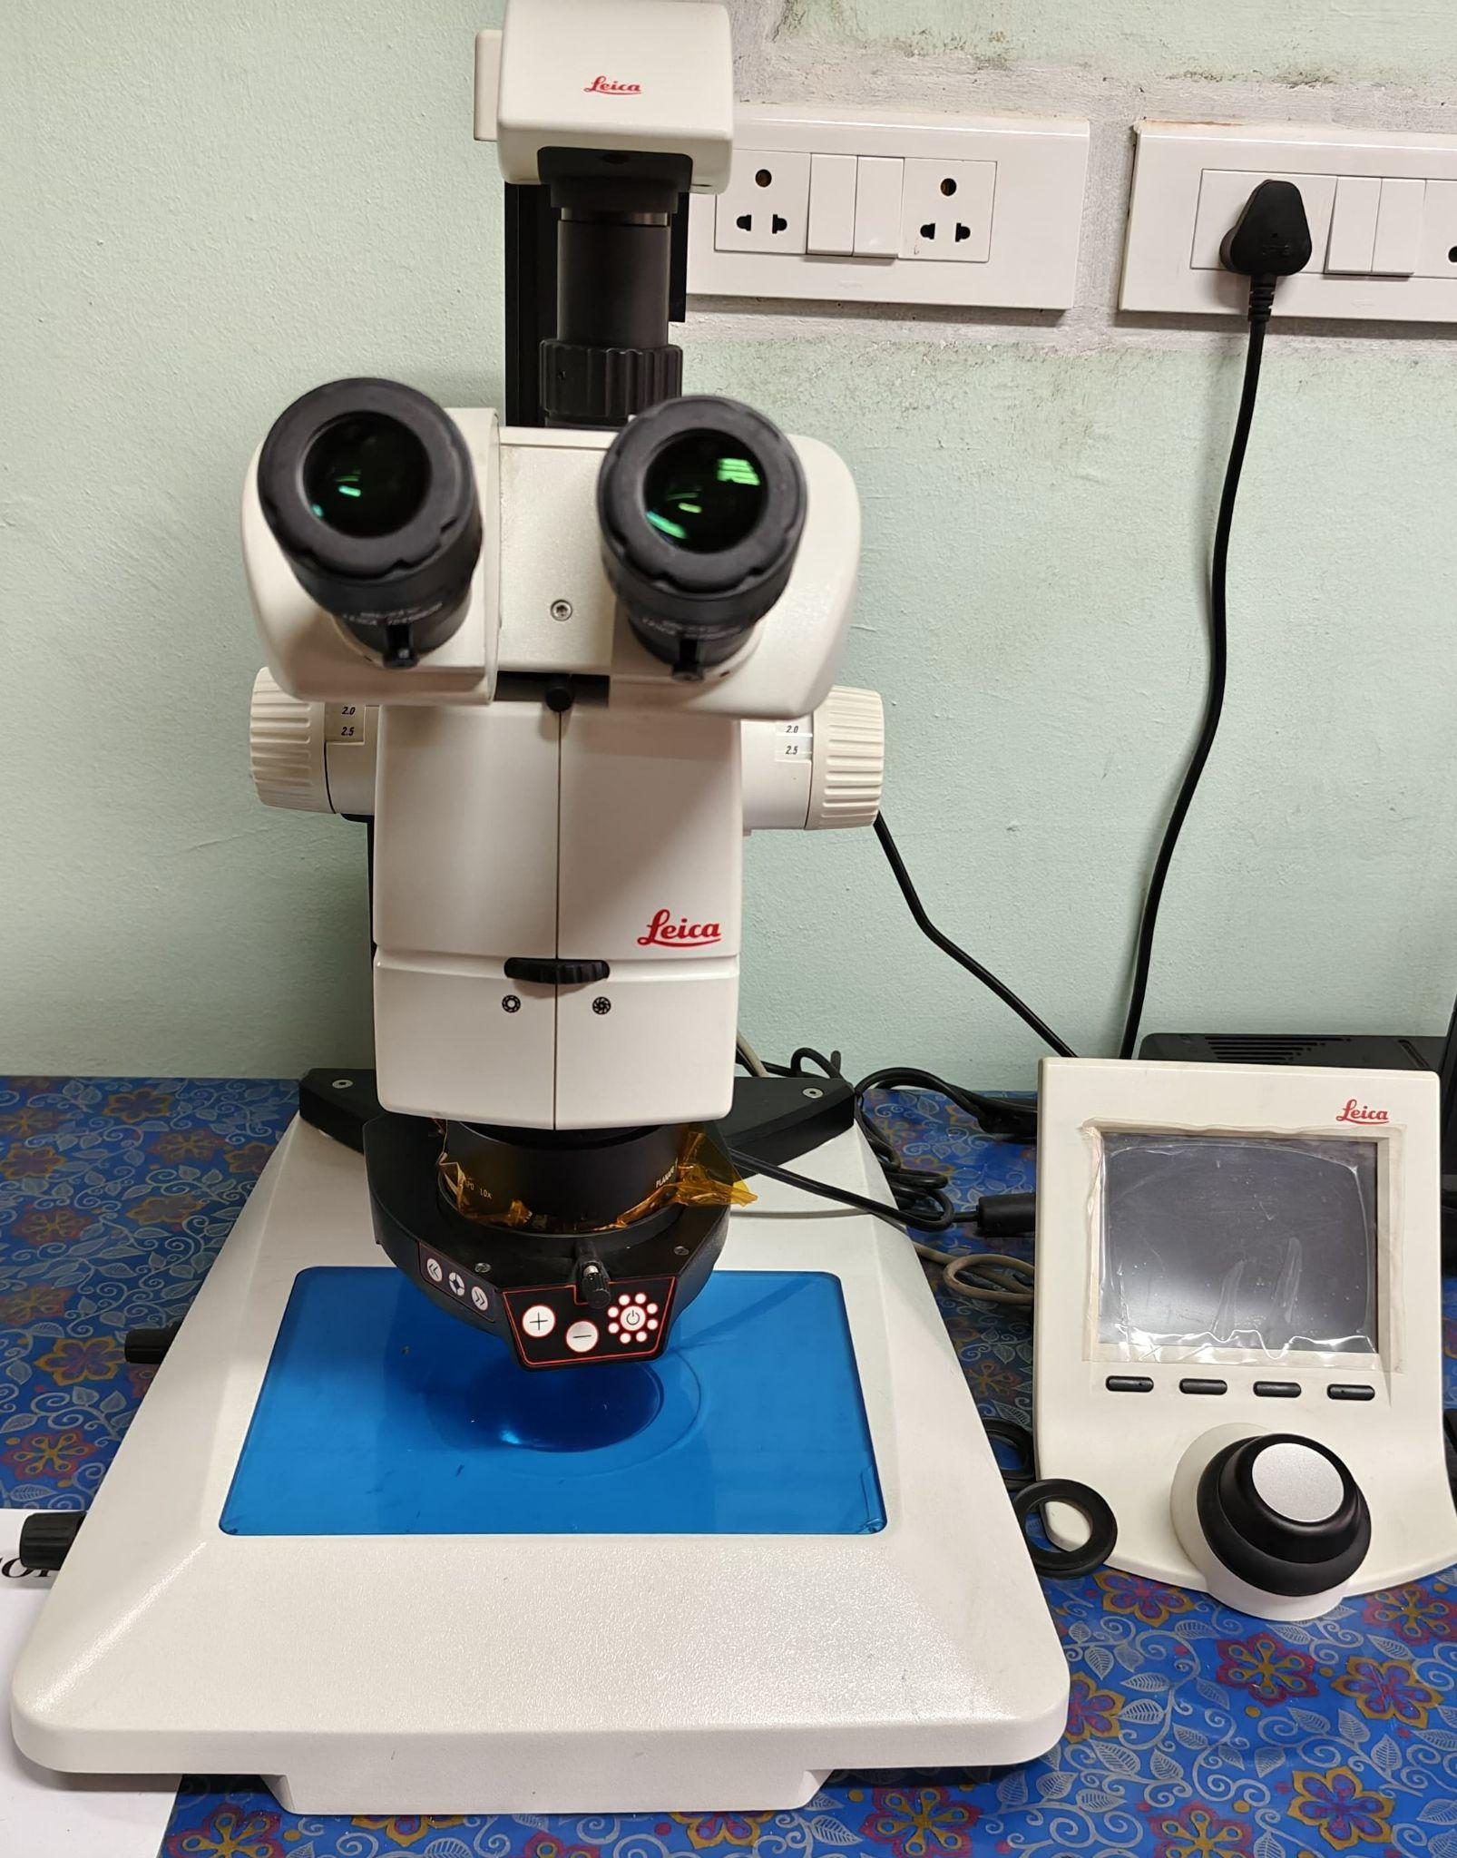 | Name of the equipment:  Sterio Microscope with 5 MP HD Microscope Camera  Make & Model:  High Performance Sterio Microscope: Leica M165 C  Microscope Camera: MC170 HD 5MP  I-Stem Registration ID-  ……………………..  Category of Instrument  Optical Imaging/Microscopy/  Characterisation & Testing  Types of Analysis / Testing  - High-resolution stereo imaging  - Sample observation & documentation  Application:  - Environmental sample inspection (microplastics, sediments, biofilms)  - Material surface analysis  - Morphological Analysis  - Biological specimen observation (insects, plant structures, etc.)  - Quality control in industrial and research applications  Description of Instrument  A stereo microscope, also known as a dissecting microscope or stereomicroscope, is a type of optical microscope designed for low magnification observation of three-dimensional objects. Unlike compound microscopes which are typically used for high magnification viewing of thin, two-dimensional specimens such as cells or microorganisms, stereo microscopes are optimized for observing larger, solid objects like rocks, insects, plants, circuit boards, and other macroscopic specimens.
Booking Details

Book through I-STEM:  https://www.istem.gov.in/  Slot Booking Link  I-STEM Slot Booking link for External User | Booking available for  Internal and External Both  Requisition form for  Internals  Externals

Contact Details

Faculty In-charge:  Dr. Anantha Singh T S  Dr. Bhaskar S  Email ID:  singh87@nitc.ac.in  bhaskars@nitc.ac.in  Phone number:  Anantha Singh: +91-8758790511  Bhaskar S: +91-9742720843 | Technical Staff:  Fashid V C (TA) fashidvc@nitc.ac.in  Amardeep KV (Technician)  amardipkumarv@nitc.ac.in | Department  CED  Office Email ID  cedoffice@nitc.ac.in  Location  Environmental Engineering Laboratory, Department of Civil Engineering  Lab Phone No  0495 228 6247
Features, Working Principle and Specifications

Features of the equipment  - Motorized zoom & focus for precise adjustments  - Apochromatic optics for superior colour correction  - Integrated LED illumination (transmitted & reflected)  - Ergonomic design for long-duration use  - HD camera with real-time imaging | Unique features/Measurement capabilities, if any  - 8:1 Zoom Range (0.78x–12.5x magnification)  - High-resolution imaging (5MP MC170 HD camera)  - Software compatibility (Leica Application Suite for image capture & analysis)
Instrument Technical Description and Major Specifications  (This Specifications Limited to Major 5)  - Optical System:  - Magnification Range: 7.8x – 125x  (with 10x eyepiece)  - Working Distance: 60mm (standard)  - Field of View: 30.5mm (at 1x)  - Resolution: 864 lp/mm (with 2x objective)  - Illumination:  - LED transmitted & incident light (adjustable intensity)  - Camera Specifications (MC170 HD):  - Resolution: 5MP (2592 x 1944 pixels)  - Frame Rate: 15fps @ full resolution  - Sensor Type: CMOS (color)  - Software Compatibility:  - Leica Application Suite (LAS) for image capture & measurements  - Supported File Formats:  - .JPG, .PNG, .TIFF | Measurement/Sample specifications:  - Sample Size  - Max height: 60mm (working distance)  - Recommended: <50mm thick for optimal focus  - Sample Type:  - Solid or semi-solid (no liquids)  - Reflective & non-reflective surfaces  - Sample Preparation:  - Should be dry & stable for imaging  - No hazardous/corrosive materials

Type of Sample Required for Analysis / Testing (Quantity, Pre-Preparation, State etc.)

- Quantity: Single specimen (must fit within the 60mm working distance)
- State: Dry or fixed (no wet/unsealed samples)
- Sample Type: Solid or semi-solid (e.g., microplastics, insects, plant parts, engineered materials)
- Size Limitations: Max height: 60mm (recommended <50mm for optimal focus)
- Material Restrictions:
  - No liquids, gels, or volatile substances
  - No corrosive/hazardous materials

Guidelines for Sample Submission – User Instructions

- Pre-Preparation:
  - Ensure samples are clean and dust-free
  - Reflective surfaces should be matte-coated if glare interferes with imaging
- Documentation: Provide sample details (material, expected features, areas of interest)
- Submission Protocol:
  - Max samples per session: 1 (sequential imaging for multiple specimens)
  - Advance booking required for time-sensitive samples
- Turnaround Time:
  - 30 minutes to 2 hours (depends on complexity and required magnification)
- Output Delivery:
  - Images provided in .JPG, .PNG, or .TIFF format
  - Optional measurements/data via Leica Application Suite (LAS)

User Charges Rs. (GST Extra)

Internal | External Academic Institutes | National R&D Lab | Industry
300/- per sample | 600/- per sample | 600/- per sample | 1200/- per sample

