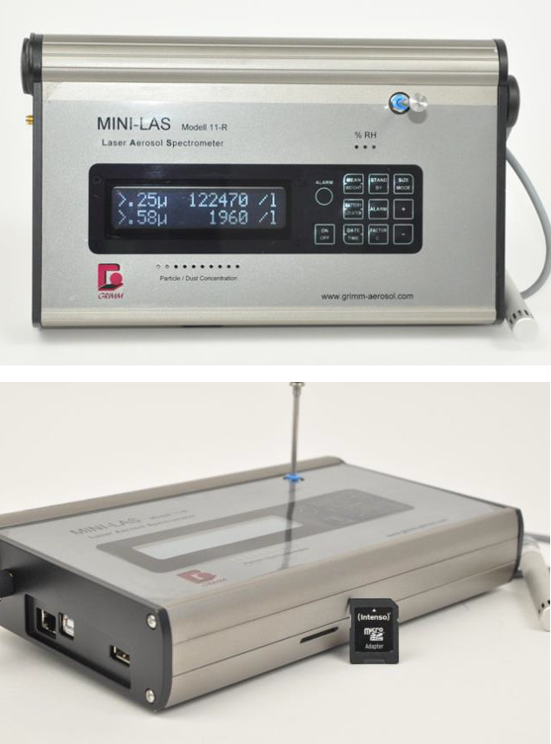 | Portable Laser Aerosol Spectrometer  Name of the equipment:  Portable Laser Aerosol Spectrometer (LAS)  Make & Model:  Grimm Portable LAS Model: 11-R  I-Stem Registration ID-  3220813  Category of Instrument  - Environmental Monitoring  - Aerosol Science  Types of Analysis / Testing  - Real-time aerosol particle size distribution & concentration measurement  Application:  - Air quality monitoring (ambient conditions of indoor measurements)  - Workplace Exposure assessment  - Pollution source characterization  Description of Instrument  A portable, high-resolution aerosol spectrometer for real-time particle analysis in environmental and industrial settings.
Booking Details

Contact Details
Book through I-STEM:  https://www.istem.gov.in/  Slot Booking Link  I-STEM Slot Booking link for External User | Booking available for  Internal and External Both  Requisition form for  Internals  Externals

Faculty In-charge:  Dr. Anantha Singh T S  Dr. Bhaskar S  Email ID:  singh87@nitc.ac.in  bhaskars@nitc.ac.in  Phone number:  Anantha Singh: +91-8758790511  Bhaskar S: +91-9742720843 | Technical Staff:  Fashid V C (TA) fashidvc@nitc.ac.in  Amardeep KV (Technician)  amardipkumarv@nitc.ac.in | Department  CED  Office Email ID  cedoffice@nitc.ac.in  Location  Environmental Engineering Laboratory, Department of Civil Engineering  Lab Phone No  0495 228 6247

Features, Working Principle and Specifications  Features of the equipment  - 31-channel optical particle sizing (0.25 - 32 µm)  - Robust, battery-operated design for field use (optional)  - Data logging & real-time display | Unique features/Measurement capabilities, if any  - High time resolution (6 sec – 1 hr adjustable)  - Simultaneous PM1, PM2.5, PM10 concentration (number and mass) measurement
Instrument Technical Description and Major Specifications  (This Specifications Limited to Major 5)  - Size Range: 0.25 – 32 µm (31 size bins)  - Flow Rate: 1.2 L/min (controlled)  - Concentration Range: 0 – 2,000,000 particles/L  - Data Output: Particle number & mass distribution  - Power Supply: 18V DC / Battery operation (8 hrs) | Measurement/Sample specifications:  - Sample Type: Airborne particles (aerosols)  - Sampling Environment: 0 – 75% RH (non-condensing)  - Operating Temp: 0 – 40°C  - Calibration: ISO 21501-4 compliant
Type of Sample Required for Analysis / Testing (Quantity, Pre-Preparation, State etc.)

- Quantity: Continuous real-time sampling (no fixed volume; operates on air flow)
- State: Airborne particulate matter (aerosols)
- Pre-Preparation: None required (direct ambient air intake)
- Compatibility:
  - Non-corrosive gases
  - Non-condensing conditions (0–75% RH)
  - Temperature Range: 0-40 °C
Guidelines for Sample Submission

- Before Measurement:
  - Perform a zero-check using HEPA-filtered air if high accuracy is required.
  - Ensure the inlet is unobstructed and free from debris.
- During Measurement:
  - Avoid sampling in fog, rain, direct sunlight or condensation.
  - For stack/ducted sampling, use an appropriate dilution system if particle concentration exceeds 2,000,000 particles/L.

- Data Handling:
  - The Mini-LAS 11-R can be controlled both directly and remotely. With its comprehensive interface configuration (Bluetooth, USB, LAN, RS232), it is flexible in regards to data transmission and only limited by the maximum cable length or effective range of the wireless connection.
  - For long-term monitoring, external power is recommended.
- Safety Notes:
  - Do not expose the device to explosive atmospheres.
  - Clean the inlet nozzle periodically if used in high-dust environments.

User Charges Rs. (GST Extra)

Internal | External Academic Institutes | National R&D Lab | Industry
1000/-  per hour | 2000/-  per hour | 2000/-  per hour | 4000/-  per hour

