High-Performance Liquid Chromatography (HPLC) System
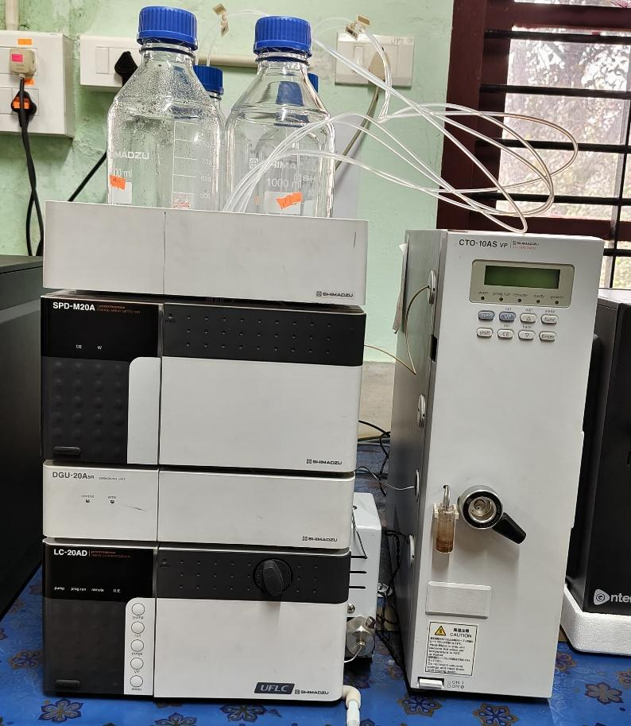 | Name of the equipment:  High-Performance Liquid Chromatography (HPLC) System  Make & Model:  Shimadzu Prominence HPLC System  I-Stem Registration ID-  3220814  Category of Instrument  Analytical Chemistry  Types of Analysis / Testing  - Quantitative and qualitative analysis of compounds  - High-performance liquid chromatography (HPLC) separations  Application:  - Pharmaceutical analysis  - Environmental monitoring  - Food & beverage testing  - Biochemical research  Description of Instrument  - Modular HPLC system for precise and reproducible separations  - Ideal for research, QC, and routine analysis in academic, industrial, and clinical labs.
Booking Details
Book through I-STEM:  https://www.istem.gov.in/  Slot Booking Link  I-STEM Slot Booking link for External User | Booking available for  Internal and External Both  Requisition form for  Internals  Externals
Contact Details

Faculty In-charge:  Dr. Anantha Singh T S  Dr. Bhaskar S  Email ID:  singh87@nitc.ac.in  bhaskars@nitc.ac.in  Phone number:  Anantha Singh: +91-8758790511  Bhaskar S: +91-9742720843 | Technical Staff:  Fashid V C (TA) fashidvc@nitc.ac.in  Amardeep KV (Technician)  amardipkumarv@nitc.ac.in | Department  CED  Office Email ID  cedoffice@nitc.ac.in  Location  Environmental Engineering Laboratory, Department of Civil Engineering  Lab Phone No  0495 228 6247
Type of Sample Required for Analysis / Testing (Quantity, Pre-Preparation, State etc.)
Features, Working Principle and Specifications
Features of the equipment  - Binary Pump (LC-20AD) – High-pressure mixing with precise flow control (0.001–10.000 mL/min)  - Degassing Unit (DGU-20A5R) – Online degassing for stable baselines  - Diode Array Detector (SPD-M20A) – Wide wavelength range (190–800 nm) for multi-component analysis  - Column Oven (CTO-10AS VP) – Precise temperature control (5–85°C) for improved separation  - LabSolutions Software – User-friendly interface for method setup, data acquisition, and analysis | Unique features/Measurement capabilities, if any  - High sensitivity detection (low noise levels for trace analysis)  - Wavelength programmability for optimal peak resolution  - Auto-validation and compliance-ready (21 CFR Part 11 optional) Mass Range (MS): 1.2 – 1100 amu
Instrument Technical Description and Major Specifications  (This Specifications Limited to Major 5)  - Flow Rate Range: 0.001–10.000 mL/min  - Pressure Range: 0–40 MPa (400 bar)  - Wavelength Range (DAD): 190–800 nm  - Temperature Range (Column Oven): 5–85°C (±0.1°C accuracy)  - Injection Volume: 0.1–100 µL (manual/injection loop) | Measurement/Sample specifications:  - Sample State: Liquid (filtered, 0.2–0.45 µm recommended)  - Solvent Compatibility: Water, organic solvents (ACN, MeOH, etc.)  - Sample Volume Required: Typically, 10–100 µL (depends on method)  - Maximum Sample Concentration: ≤10 mg/mL (to avoid column overloading)

- Sample State:
  - Liquid (must be fully dissolved, no particulates)
  - Filtered (0.2–0.45 µm syringe filter recommended)
- Quantity:
  - Minimum volume: 0.5 mL (for multiple injections)
  - Ideal volume: 1–2 mL (for method development/repeat analysis)
- Pre-Preparation Requirements:
  - Solvent compatibility: Must be soluble in HPLC-grade solvents (e.g., water, acetonitrile, methanol)
  - Concentration range: ≤10 mg/mL (to prevent column overloading)
  - Stability: Chemically stable under analytical conditions (specify if light-/heat-sensitive)
- Type of Samples Analyzed:
  - Small organic molecules, pharmaceuticals, peptides, natural products, environmental pollutants

Guidelines for Sample Submission – User Instructions

- Submission Protocol:
  - Clearly label samples with:
    - Sample name/ID
    - Solvent used
    - Expected concentration (if known)
- Documentation: Provide a datasheet specifying:
  - Target analyte(s)
  - Preferred detection wavelength (if applicable)
  - Special requirements (e.g., gradient elution, column type)
- User Instructions:
  - For manual injection: Deliver samples in HPLC vials with crimp/septum caps.
  - Hazardous samples: Notify staff in advance (e.g., toxic/corrosive compounds).
- Prohibited:
  - Particulate-containing samples (unfiltered)
  - Highly viscous samples (may clog system)
  - Non-volatile buffers (e.g., phosphates) without prior approval
- Turnaround Time:
  - Routine analysis: 1–2 days (standard methods)
  - Method development/validation: 3–5 days (requires consultation)
- Maximum Samples per Batch: 1 sample per run

User Charges Rs. (GST Extra)

Internal | External Academic Institutes | National R&D Lab | Industry

