Fourier Transform Infrared (FTIR) Spectrometer
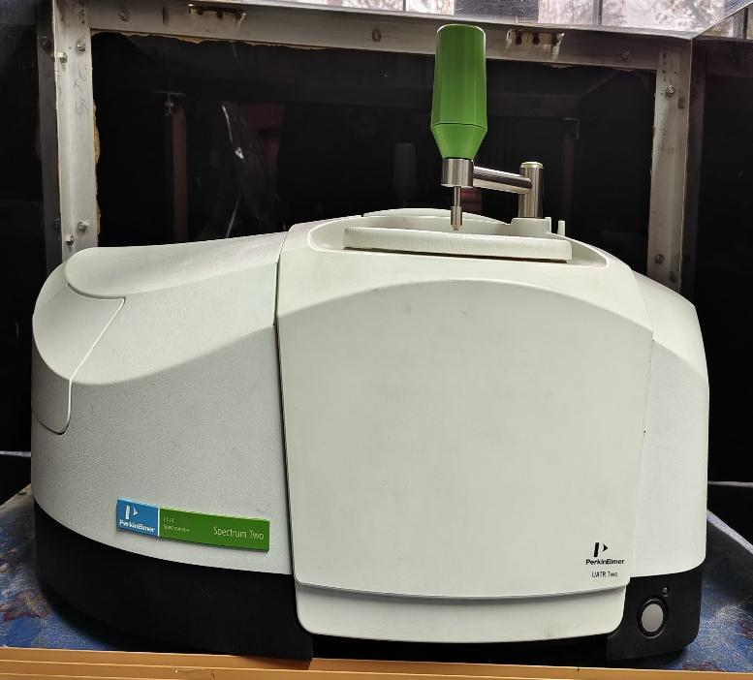 | Name of the equipment:  Fourier Transform Infrared Spectrometer  Make & Model:  Perkin Elmer Spectrum 2  I-Stem Registration ID-  …………………………  Category of Instrument  Analytical Chemistry  Types of Analysis / Testing  - Material Identification  - Functional Group Analysis  - Quantitative and Qualitative Chemical Characterisation  Application:  - Pollutant Analysis  - Polymer Degradation Studies  - Soil and Water Quality Assessment  - Pharmaceutical and industrial Quality Control  Description of Instrument  A Fourier Transform Infrared Spectrometer for rapid, non-destructive chemical analysis of solids, liquids, and gases.
Booking Details
Book through I-STEM:  https://www.istem.gov.in/  Slot Booking Link  I-STEM Slot Booking link for External User | Booking available for  Internal and External Both  Requisition form for  Internals  Externals
Contact Details

Faculty In-charge:  Dr. Anantha Singh T S  Dr. Bhaskar S  Email ID:  singh87@nitc.ac.in  bhaskars@nitc.ac.in  Phone number:  Anantha Singh: +91-8758790511  Bhaskar S: +91-9742720843 | Technical Staff:  Fashid V C (TA) fashidvc@nitc.ac.in  Amardeep KV (Technician)  amardipkumarv@nitc.ac.in | Department  CED  Office Email ID  cedoffice@nitc.ac.in  Location  Environmental Engineering Laboratory, Department of Civil Engineering  Lab Phone No  0495 228 6247

Features, Working Principle and Specifications

Features of the equipment  - High-sensitivity DLATGS (deuterated L-Alanine doped triglycin Sulfate) detector for accurate spectral data  - Universal ATR (Attenuated Total Reflectance) accessory for solid/liquid samples  - Sealed and desiccated optics for moisture-sensitive measurements | Unique features/Measurement capabilities, if any  - Spectral range: 4,000–400 cm⁻¹  - Resolution: Up to 0.5 cm⁻¹  - Auto-alignment and real-time diagnostics for consistent performance
Instrument Technical Description and Major Specifications  (This Specifications Limited to Major 5)  - Spectral Range: 4,000–400 cm⁻¹  - Resolution: 0.5–4 cm⁻¹ (adjustable)  - Detector: DLATGS (standard), optional liquid N₂-cooled MCT for enhanced sensitivity  - Beam Splitter: KBr for mid-IR range  - Supported File Formats: .spa, .csv, .jcamp | Measurement/Sample specifications:  - Sample Type  Solid (powder/film), liquid, gel  - Sample Quantity  Solids: 1-10mg  Liquids: Thin Film (µL volume)  - Pre Preparation  Solids: Dry Finely Ground (for KBr Pellets)  Liquids: Free of Bubbles/Suspended Particles  - Restrictions  No Corrosive or Highly Volatile solvents  Samples must be IR transparent in measure range
Type of Sample Required for Analysis / Testing (Quantity, Pre-Preparation, State etc.)

- Liquids
  - Quantity: 5–20 µL (thin film for ATR) or 1–2 drops for liquid cells.
  - State: Homogeneous, free of bubbles/suspended particles.
  - Pre-Preparation:
    - Volatile liquids: Use sealed cells to prevent evaporation.
    - Viscous liquids: Apply directly to ATR crystal and ensure even coverage.
- Solids
  - Quantity: 1–10 mg (for KBr pellets) or thin films for ATR.
  - State: Dry, finely ground powder (particle size <2 µm to reduce scattering).
  - Pre-Preparation:
    - KBr Pellets: Mix 0.2–1% sample with anhydrous KBr; press at 8–10 tons.
    - ATR: Flatten solid against crystal (e.g., with pressure clamp).
- Gases
  - Quantity: 10–50 mL (sealed gas cell required).
  - State: Dry, non-corrosive.
- Restrictions: Avoid samples containing water (interferes with IR bands) and corrosive substances (e.g., strong acids) that damage optics.

Guidelines for Sample Submission – User Instructions

- General Instructions
  - Labelling: Clearly mark samples with Name/ID, Solvent used (if applicable), Expected functional groups (e.g., "suspected carbonyl peak").
  - Containers: Use clean glass vials or airtight containers for hygroscopic samples.
- Liquid Samples
  - ATR Method:
    - Place a drop on the ATR crystal.
    - Lower the pressure arm evenly to form a thin film.
    - Wipe crystal with methylene chloride → ethanol post-use.
  - Transmission Cells: Ensure spacer thickness matches solvent (e.g., 0.1 mm for organic solvents).
- Solid Samples (KBr Pellets)
  - Grinding:
    - Mix 1–2 mg sample + 100 mg dry KBr in a mortar.
    - Grind briefly (over-grinding absorbs humidity).
  - Pressing:
    - Load mixture into pellet die.
    - Press at 8–10 tons for 1–2 minutes.
  - Storage: Keep pellets in a desiccator until analysis.
- Cleaning Protocols
  - ATR Crystal: Wipe with solvent (acetone → ethanol) and polish if scratched.
  - KBr Plates: Clean with methylene chloride, then dry in the oven (100°C).
- Turnaround & Limits
  - Max Samples/Batch: 10.
  - Analysis Time: 1–2 days (priority scheduling available).
User Charges Rs. (GST Extra)

Internal | External Academic Institutes | National R&D Lab | Industry
300/- per sample | 600/- per sample | 600/- per sample | 1200/- per sample

