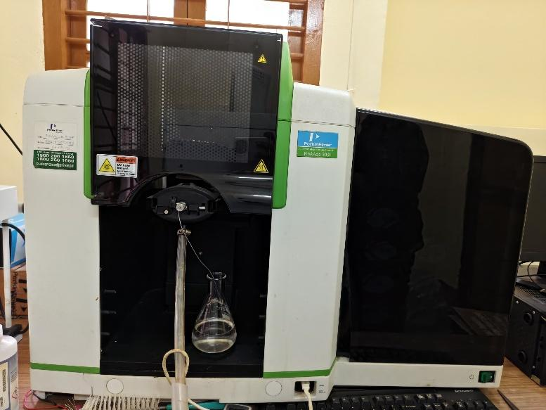 | Gas Chromatograph (GC) and Mass Spectrometer (MS)  Name of the equipment:  Gas Chromatograph and Mass Spectrometer  Make & Model:  GC: Perkin Elmer Clarus 580  MS: Perkin Elmer Clarus SQ 8 S  I-Stem Registration ID-  3222319  Category of Instrument  Analytical Chemistry  Types of Analysis / Testing  - Separation, identification, and quantification of volatile and semi-volatile compounds;  - High-sensitivity mass spectrometric detection;  - Qualitative and quantitative analysis of complex mixtures  Application:  - Pharmaceutical analysis  - Environmental testing (viz. VOC analysis)  - Forensics & toxicology  - Food & flavour analysis  - Petrochemical & industrial chemistry  Description of Instrument  A high-performance GC-MS system combining the Clarus 580 GC (precise separation with advanced temperature control) and the Clarus SQ 8S MS (single quadrupole MS for reliable compound identification).
Booking Details

Book through I-STEM:  https://www.istem.gov.in/  Slot Booking Link  I-STEM Slot Booking link for External User | Booking available for  Internal and External Both  Requisition form for  Internals  Externals

Contact Details

Faculty In-charge:  Dr. Anantha Singh T S  Dr. Bhaskar S  Email ID:  singh87@nitc.ac.in  bhaskars@nitc.ac.in  Phone number:  Anantha Singh: +91-8758790511  Bhaskar S: +91-9742720843 | Technical Staff:  Fashid V C (TA) fashidvc@nitc.ac.in  Amardeep KV (Technician)  amardipkumarv@nitc.ac.in | Department  CED  Office Email ID  cedoffice@nitc.ac.in  Location  Environmental Engineering Laboratory, Department of Civil Engineering  Lab Phone No  0495 228 6247

Features, Working Principle and Specifications

Features of the equipment  - Dual-detection capability (GC with FID/MS for flexible analysis)  - Advanced electronic pressure control (EPC) for precise flow regulation  - Universal MS compatibility with multiple ionization modes (EI) | Unique features/Measurement capabilities, if any  - Mass Range (MS): 1.2 – 1100 amu  - Scan Speed (MS): Up to 10,000 amu/sec  - Detection Limit (GC-MS): Sub-ppb level sensitivity  - Integrated TurboMass/Simplicity software for automated method setup & data analysis
Instrument Technical Description and Major Specifications  (This Specifications Limited to Major 5)  - GC Column Oven Temp Range: Ambient +4°C to 450°C  - MS Ion Source Temp: Up to 350°C  - Pressure Range (GC): 0 – 150 psi  - Mass Spectrometer Resolution: Unit resolution (1 amu)  - Data Acquisition Speed: Up to 20 spectra/second | Measurement/Sample specifications:  - Sample Type: Volatile & semi-volatile organic compounds  - Injection Volume (GC): 0.1 – 2 µL (liquid), 1 – 1000 mL (gas)  - Mass Spec Compatibility: EI (Electron Ionization) only  - Column Compatibility: Capillary columns (0.1 – 0.53 mm ID)  - Carrier Gas: Helium, Hydrogen, or Nitrogen

Type of Sample Required for Analysis / Testing (Quantity, Pre-Preparation, State etc.) Guidelines for Sample Submission – User Instructions

- Quantity:
  - Liquid: 1 – 2 mL (for dilution if needed)
  - Gas: 50 – 100 mL (in sealed vials)
- Pre-Preparation:
  - Must be filtered (0.45 µm) to remove particulates
  - Should be in volatile solvent (e.g., methanol, acetone, hexane)
  - No heavy salts or non-volatile buffers
- User Instructions:
  - Provide expected compounds (if known)
  - Specify required sensitivity (ppm/ppb)
- Type of Samples Analysed:
  - Organic compounds (drugs, pollutants, flavours, etc.)
  - Not suitable for metals, polymers, or inorganic salts
  - Maximum No. of Samples Accepted at a Time: 10 (batch processing possible)
  - Minimum No. of Days Required for Analysis: 2–5 days (depends on complexity)
- Maximum No. of Samples Accepted at a Time: 10 (batch processing possible)
- Minimum No. of Days Required for Analysis: 2–5 days (depends on complexity)

User Charges Rs. (GST Extra)

Internal | External Academic Institutes | National R&D Lab | Industry
1500 per sample | 3000 per sample | 3000 per sample | 6000 per sample

