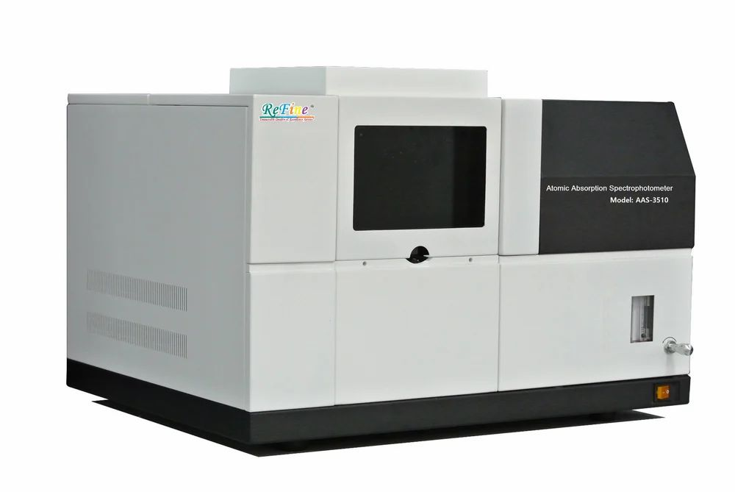 | Atomic Absorption Spectrophotometer  Name of the equipment:  Atomic Absorption Spectrophotometer  Make & Model:  Perkin Elmer PinAAcle 900F  I-Stem Registration ID-  3222318  Category of Instrument  - Advanced Manufacturing facility  - Characterization & Testing  - Computational Facility  - Bioscience & Technology  - Sample preparation  Types of Analysis / Testing  - Elemental analysis (metals and semi-metals)  - Quantitative determination in liquid/solid samples  Application:  - Heavy metal detection in water, soil, and industrial waste  - Food safety (trace metal contaminants)  - Pharmaceutical and chemical industry quality control  - Metal Detection in Archaeology, Mining, Forensics, Manufacturing etc.  Description of Instrument  A high-performance flame AA spectrometer with a true double-beam design for fast startup and long-term stability. Features fiber-optic light throughput for improved detection limits, an 8-lamp turret, and automated flame optimization. Controlled by Syngistix™ for AA software for streamlined workflows, with optional 21 CFR Part 11/EU Annex 11 compliance for regulated labs.

Booking Details

Book through I-STEM:  https://www.istem.gov.in/  Slot Booking Link  I-STEM Slot Booking link for External User | Booking available for  Internal and External Both  Requisition form for  Internals  Externals
Contact Details

Faculty In-charge:  Dr. Anantha Singh T S  Dr. Bhaskar S  Email ID:  singh87@nitc.ac.in  bhaskars@nitc.ac.in  Phone number:  Anantha Singh: +91-8758790511  Bhaskar S: +91-9742720843 | Technical Staff:  Fashid V C (TA) fashidvc@nitc.ac.in  Amardeep KV (Technician)  amardipkumarv@nitc.ac.in | Department  CED  Office Email ID  cedoffice@nitc.ac.in  Location  Environmental Engineering Laboratory, Department of Civil Engineering  Lab Phone No  0495 228 6247

Features, Working Principle and Specifications

Features of the equipment  - Double-beam optics for stability & precision  - 8-lamp turret with automatic alignment  - Fiber-optic light path for enhanced sensitivity  - Automated flame/burner optimization  - Syngistix™ software with compliance options | Unique features/Measurement capabilities, if any  - Fast startup (<10 min) with self-diagnostics  - Detection limits: Low ppm to sub-ppm range  - TurboCharge nebulizer for improved uptake
Instrument Technical Description and Major Specifications  (This Specifications Limited to Major 5)  - Wavelength Range: 190–900 nm  - Spectral Bandwidth: 0.2, 0.7, 1.4 nm  - Flame Types: Air-Acetylene / Nitrous Oxide-Acetylene  - Burner Head: 10 cm titanium  - Lamp Mount: 8-position auto-switching | Measurement/Sample specifications:  - Sample State: Liquid (acid-digested)  - Volume Required: 2–5 mL (flame)  - Pre-Preparation: Acid digestion (HNO₃/HCl) for solids  - Detection Elements: Pb, Cd, Cu, Zn, Fe, etc.

Type of Sample Required for Analysis / Testing (Quantity, Pre-Preparation, State etc.)

- Quantity:
  - Minimum 20 mL of liquid sample per element (filtered through 0.2 μm filter)
  - Volume may vary based on expected concentration
- Pre-Preparation:
  - Samples must be acid-digested (e.g., HNO₃/HCl) if solid/sludge
  - Filtered (0.2 μm) to remove particulates
  - pH-adjusted if necessary (e.g., for preservation)
- State:
  - Liquid only (aqueous matrix preferred)
  - No organic solvents without prior consultation
Guidelines for Sample Submission

- Standards Required for Quantitative Analysis
  - Provide certified standards for each target element.
  - Each element & standard counts as a separate sample (charged accordingly).
  - If standards are not provided, only absorbance values will be reported (no quantification).
- Sample Processing
  - All samples (standards + unknowns) processed using client-provided method.
  - Raw data only will be provided (no advanced data interpretation).
- Minimum Sample Requirement
  - Batch processing: Minimum 20 total samples (standards + unknowns) per run.
  - Smaller batches may incur additional charges.
- Submission Notes
  - Label samples clearly with element(s) of interest and expected concentration range.
  - Hazardous samples (e.g., HF-containing) require prior approval.

User Charges Rs. (GST Extra)

Internal | External Academic Institutes | National R&D Lab | Industry
200/-  per sample per metal | 400/-  per sample per metal | 400/-  per sample per metal | 1000/-  per sample per metal

