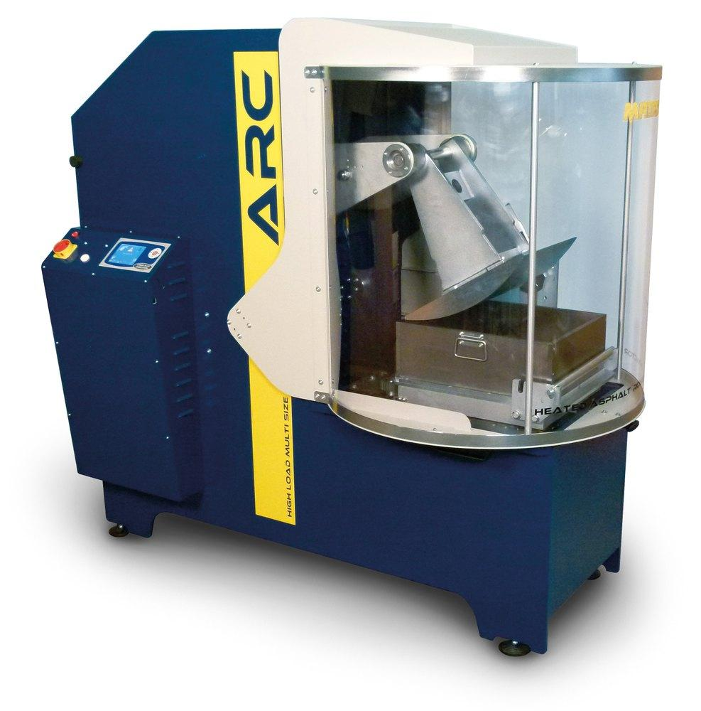  HEATED ASPHALT ROLLER COMPACTOR | Name of the equipment:  Heated Asphalt Roller Compactor  Make & Model:  B039 Roller Compactor  I-Stem Registration ID-  —-----------  Category of Instrument  Sample preparation  Types of Analysis / Testing  Sample Preparation  Application:  Highway Engineers  Bitumen Manufacturers  Road Construction Companies  Description of Instrument  It is used to produce representative sample slabs of several dimensions of bituminous mixtures laid and compacted on site..
Booking Details

Book through I-STEM:  https://www.istem.gov.in/  Slot Booking Link  I-STEM Slot Booking link for External User | Booking available for  Internal and External Both  Requisition form for  Internals  Externals  Contact Details
Faculty In-charge:  Dr. M. Sivakumar  Email ID:  sivakumarm@nitc.ac.in  Phone number:  04952286232 | Technical staffs:  Chandni P R  chandnipr@nitc.ac.in  Ajin Das C K  ajindasck@nitc.ac.in  Abhiraj A R  abhirajar@nitc.ac.in | Department  CED  Office Email ID  cedoffice@nitc.ac.in  Location  Pavement Engineering Laboratory  Lab Phone No  0495-2286243

Features, Working Principle and Specifications
Features of the equipment  - Electro-mechanical system: No air or hydraulic pressure  - Programmable compaction: Adjustable compaction cycles  - Heating and temperature control: Maintains optimal sample workability | Unique features/Measurement capabilities, if any  - Heating of the Segment Roller: Temperature control from room to 180°C  - Programmable Compaction: Compaction cycles based on load or deformation values  - Sample Preparation: Uniform density and dimensions, with cored or cut off samples for further testing
Instrument Technical Description and Major Specifications (This Specifications Limited to Major 5)  - Control Unit (B039-02): Thermoregulator circuit, temperature probe (up to 180°C)  - Sliding Cart Heating Option (B039-03): Thermoregulated circuit with temperature probe  - Segmented Roller: Alternated rotation, programmable for specific load or deformation values | Measurement/Sample specifications:  - Ability to produce samples with uniform density and dimensions  - Sample slabs can be cored or cut off to obtain cylinders and beams for various tests, such as:  - Bending fatigue  - Indirect tensile  - Static and dynamic creep  - Stiffness  - 4-point tests

- Sample type: Bituminous mixtures
Type of Sample Required for Analysis / Testing (Quantity, Pre-Preparation, State etc.) Guidelines for Sample Submission – User Instructions
- Preparation: Representative sample slabs of various dimensions
- State: Moulded and compacted samples
- Quantity: Varies depending on test requirements
User Charges Rs. (GST Extra)

Internal | External Academic Institutes | National R&D Lab | Industry
1500/- per test | 2000/- per test | 2500/- per test | 4500/- per test

