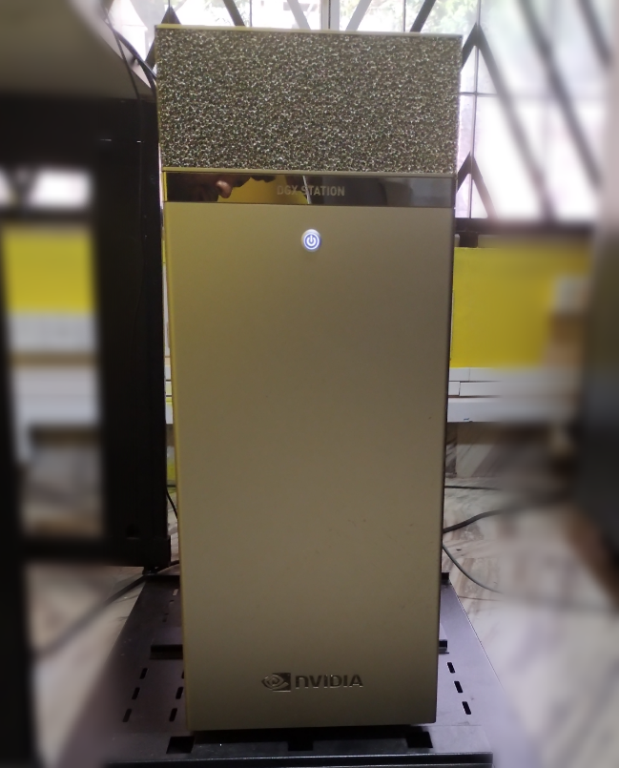 | Deep Learning System  Name of the equipment:  Deep Learning System  Make & Model:  NVIDIA DGX Station  I-Stem Registration ID:  3245584  Category of Instrument:  AI Workstation  Application: AI research and development  Description of Instrument:  AI workstation designed for deep learning and data science, featuring multiple powerful GPUs and optimized software to accelerate AI research and development.
Booking Details

Book through I-STEM:  https://www.istem.gov.in/  Slot Booking Link  Only Available for internal users | Booking available for  Internal Users  Requisition form for  Internals
Contact Details

Faculty In-charge:  Dr Raghu C  Email ID:  raghuc@nitc.ac.in  Phone number:  +91-9495066073 | Technical Staff:  R R Krishna (TA) rrkrishna@nitc.ac.in  Sajil N P (TA)  sajilnp@nitc.ac.in | Department  CCMS (Centre for Computational Modelling and Simulation)  Office Email ID  ccmsadmin@nitc.ac.in  Location  Central Computer Centre  Lab Phone No  0495-2286852

Features and Specifications

GPUs | 4 × NVIDIA A100
TFLOPS | 500
GPU Memory | 160 GB
CPU | AMD Epyc 7742 (64 Cores × 128)
System Memory | 540 GB
Storage | 9.6 TB
Software | Ubuntu LTS  DGX Recommended GPU Driver CUDA Toolkit

User Charges Rs. (GST Extra)

Internal | External Academic  Institutes | National R&D Lab | Industry
No Charges | Available only for Internal Users

