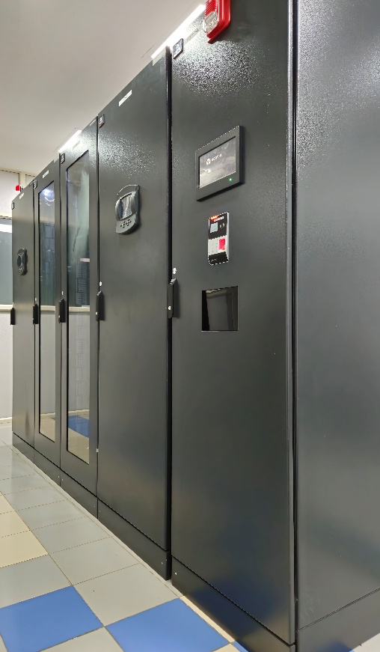 | Madhava HPC Cluster  Name of the equipment:  Madhava HPC Cluster  Make & Model:  Lenovo ThinkSystem (SR-650 and SR-630)  I-Stem Registration ID:  3245582  Category of Instrument  High Performance Computing  Application: Used to perform complex calculations and simulations that require immense computational power.  Description of Instrument  Computing Cluster for parallel computing in Science and Engineering
Booking Details

Book through I-STEM:  https://www.istem.gov.in/  Slot Booking Link  I-STEM Slot Booking link for Internal User | Booking available for  Internal  Requisition form for  Internals
Contact Details

Faculty In-charge:  Dr Raghu C  Email ID:  raghuc@nitc.ac.in  Phone number:  +91-9495066073 | Technical Staff:  R R Krishna (TA) rrkrishna@nitc.ac.in  Sajil N P (TA)  sajilnp@nitc.ac.in | Department  CCMS (Centre for Computational Modelling and Simulation)  Office Email ID  ccmsadmin@nitc.ac.in  Location  Old Library Building, Central Campus, NIT Calicut  Lab Phone No  0495-2285600

Features and Specifications

Component | Model | Processors / GPU | Memory | Storage
1 Master Node | Lenovo ThinkSystem SR-650 | 2 × Intel Xeon Gold 5218 16C 2.3GHz Processor | 192 GB
31 Compute Nodes | Lenovo ThinkSystem SR-630 | 2 × Intel Xeon Gold 6248 20C 2.5GHz Processor | 192 GB
2 GPU Nodes | Lenovo ThinkSystem SR-650 | 2 × Intel Xeon Gold 6248 20C 2.5GHz Processor  2 × NVIDIA Tesla V100 PCIe 32GB GPU | 192 GB
2 Storage Nodes | Lenovo ThinkSystem SR-630 | 2 × Xeon Silver 4208 8C 2.1GHz Processor
Storage Array | ThinkSystem DE6000H, DE6000S |  |  | 260TB
Installed Software

Quantum Mechanical Simulation Software | VASP (Vienna Ab initio Simulation Package)  Quantum ESPRESSO  Gaussian  MOLPRO  SIESTA
Molecular Dynamics Simulation Software | LAMMPS (Large-scale Atomic/Molecular Massively Parallel Simulator)  GROMACS (GROningen MAchine for Chemical Simulations)
Computational Fluid Dynamics (CFD) Software | OpenFOAM  REEF3D  DIVEMesh
Data Science and Statistical Computing | Anaconda (Distribution for Python and R)  R (Programming language for statistical computing)

User Charges Rs. (GST Extra)

Internal | External Academic  Institutes | National R&D Lab | Industry
No Charges | Available only for Internal Users

